**NAME:** Ayesha Sajjad **ROLL NO:** 2022-EE-107

**Lab 3**

# QUESTION # 1

**(a)**

**Truth Table:**

|  |  |  |  |  |  |  |  |  |  |
| --- | --- | --- | --- | --- | --- | --- | --- | --- | --- |
| A | B | C | 𝐶 | A+B | A.B | 𝐴. 𝐵 | 𝐶⊕(A+B) | (A+B)⊕𝐴. 𝐵 | [(A+B)⊕ 𝐴. 𝐵].[ A+B] |
| 0 | 0 | 0 | 1 | 0 | 0 | 1 | 1 | 1 | 0 |
| 0 | 0 | 1 | 0 | 0 | 0 | 1 | 0 | 1 | 0 |
| 0 | 1 | 0 | 1 | 1 | 0 | 1 | 0 | 0 | 0 |
| 0 | 1 | 1 | 0 | 1 | 0 | 1 | 1 | 0 | 0 |
| 1 | 0 | 0 | 1 | 1 | 0 | 1 | 0 | 0 | 0 |
| 1 | 0 | 1 | 0 | 1 | 0 | 1 | 1 | 0 | 0 |
| 1 | 1 | 0 | 1 | 1 | 1 | 0 | 0 | 1 | 1 |
| 1 | 1 | 1 | 0 | 1 | 1 | 0 | 1 | 1 | 1 |

**(b)**

**Maximum Combinational Delay In Synthesis:**

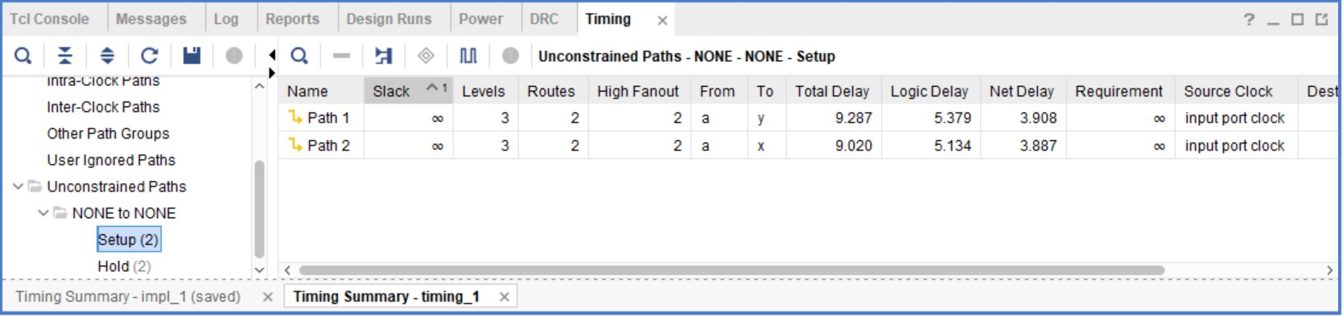

**(c)**

**Resource Utilization :**

